***MYSQL***

***Business Questions & Answer***

***On***

***Hospitals Management DataSet***

***By***

***Aman Rajbhar***

***#Count the number of hospitals by facility type.***

***SELECT***

***type, COUNT(*) AS Hospital_counts***

***FROM***

***facility***

***GROUP BY Type;***

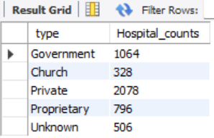

***# Find the hospitals with the highest overall rating (5 stars) in each state.***

***SELECT***

***f.Name, f.State, r.Overall AS highest_rating***

***FROM***

***facility f***

***JOIN***

***rating r ON f.Facility_ID = r.Facility_ID***

***WHERE***

***r.Overall = 5***

***GROUP BY f.Name , f.State;***

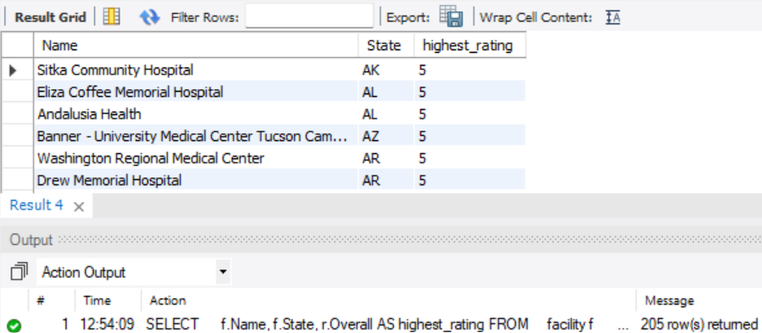

***# List hospitals where the mortality rating is below the national average.***

***SELECT***

***f.Name,f.City, f.State,r.Mortality as Mortality_Rating***

***FROM***

***facility f***

***JOIN***

***rating r ON f.Facility_ID = r.Facility_ID***

***WHERE***

***r.Mortality = 1;***

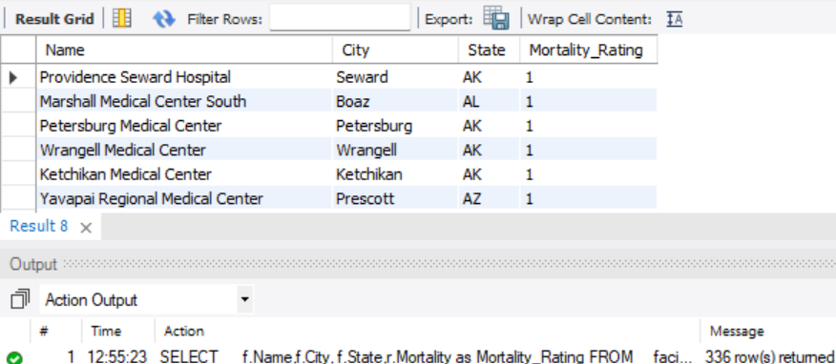

***# Compare the average overall rating between government and private hospitals***

***SELECT***

***f.Type, AVG(r.overall) AS Avg_Ovr_Rating***

***FROM***

***facility f***

***JOIN***

***rating r ON f.Facility_ID = r.Facility_ID***

***WHERE***

***f.Type IN ('Private' , 'Government')***

***GROUP BY f.Type;***

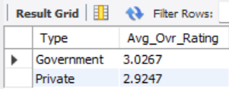

***# Find the hospitals with the highest average cost for each procedure (Heart Attack, Heart Failure, Pneumonia, Hip/Knee).***

#---------***Heart Attack***---------#

***SELECT***

***f.Name, p.Heart_Attack_Cost***

***FROM***

***facility f***

***JOIN***

***procedures p ON f.Facility_ID = p.Facility_ID***

***ORDER BY p.Heart_Attack_Cost DESC***

***LIMIT 10;***

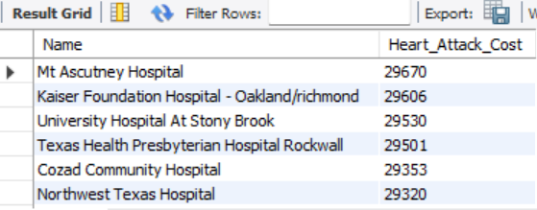

#---------***Heart Failure***---------#

***SELECT***

***f.Name, p.Heart_Failure_Cost***

***FROM***

***facility f***

***JOIN***

***procedures p ON f.Facility_ID = p.Facility_ID***

***ORDER BY p.Heart_Failure_Cost DESC***

***LIMIT 10;***

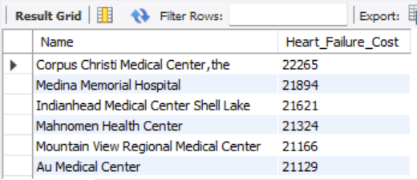

#---------***Pneumonia***---------#

***SELECT***

***f.Name, p.Pneumonia_Cost***

***FROM***

***facility f***

***JOIN***

***procedures p ON f.Facility_ID = p.Facility_ID***

***ORDER BY p.Pneumonia_Cost DESC***

***LIMIT 10;***

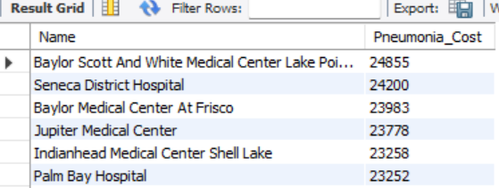

#---------***Hip/Knee***---------#

***SELECT***

***f.Name, p.Hip_Knee_Cost***

***FROM***

***facility f***

***JOIN***

***procedures p ON f.Facility_ID = p.Facility_ID***

***ORDER BY p.Hip_Knee_Cost DESC***

***LIMIT 10;***

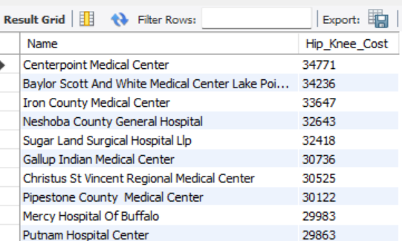

***#List hospitals that offer the value (Lower cost) for heart attack procedures.***

***SELECT***

***f.Name, p.Heart_Attack_Cost, p.Heart_Attack_Value***

***FROM***

***facility f***

***JOIN***

***procedures p ON f.Facility_ID = p.Facility_ID***

***WHERE***

***p.Heart_Attack_Value = 'Lower'***

***ORDER BY p.Heart_Attack_Cost ASC;***

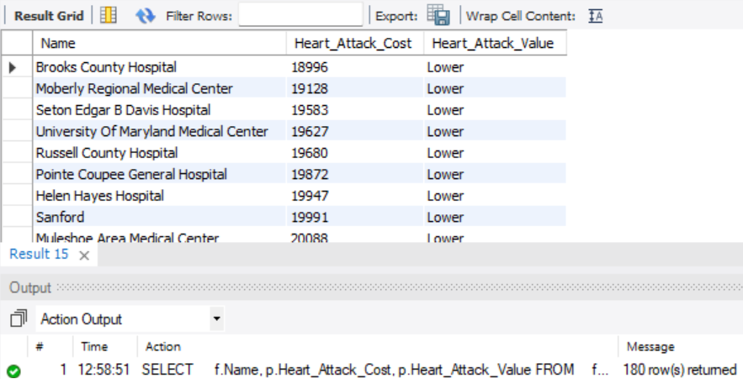

***#List hospitals that offer the value (Lower cost) for Pneumonia_Cost procedures.***

***SELECT***

***f.Name, p.Pneumonia_Cost, p.Pneumonia_Value***

***FROM***

***facility f***

***JOIN***

***procedures p ON f.Facility_ID = p.Facility_ID***

***WHERE***

***p.Pneumonia_Value = 'Lower'***

***ORDER BY p.Pneumonia_Value ASC;***

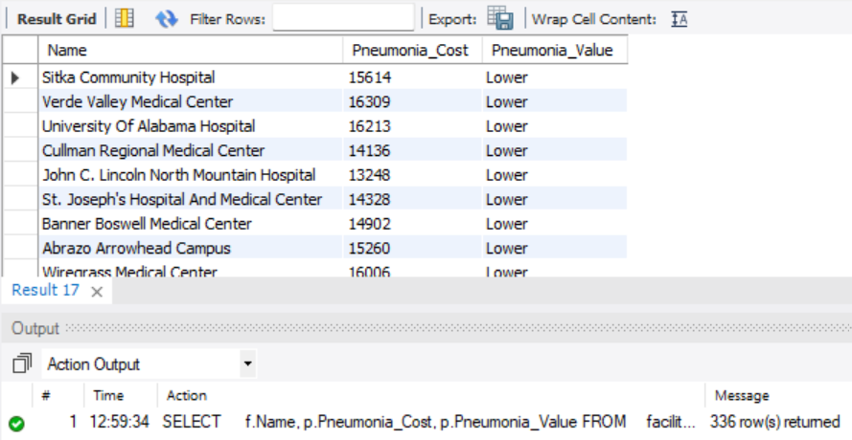

***#List hospitals that offer the value (Lower cost) for Hip_Knee_Cost procedures***.

***SELECT***

***f.Name, p.Hip_Knee_Cost, p.Hip_Knee_Value***

***FROM***

***facility f***

***JOIN***

***procedures p ON f.Facility_ID = p.Facility_ID***

***WHERE***

***p.Hip_Knee_Value = 'Lower'***

***ORDER BY p.Hip_Knee_Cost ASC;***

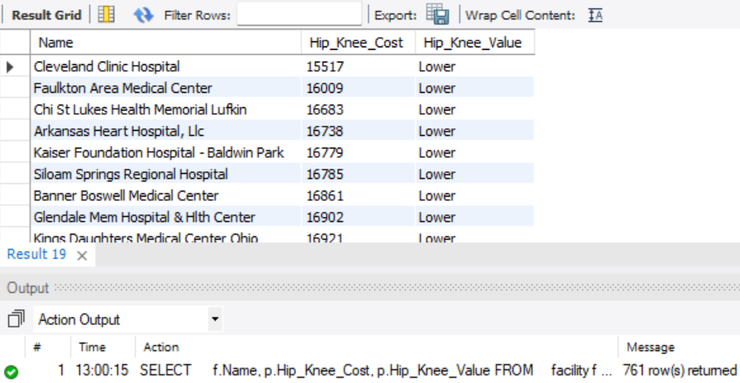

***#Compare hospitals' safety ratings across different states***.

***SELECT***

***f.State,***

***COUNT(CASE***

***WHEN r.Safety = 3 THEN 1***

***END) AS Above_safety,***

***COUNT(CASE***

***WHEN r.Safety = 1 THEN 1***

***END) AS Below_safety***

***FROM***

***facility f***

***JOIN***

***rating r ON f.Facility_ID = r.Facility_ID***

***GROUP BY f.State;***

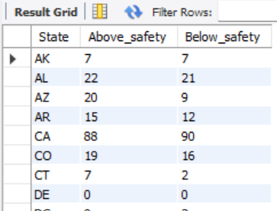

***#Compare the effectiveness of care ratings between different hospital types.***

***SELECT***

***f.Type,***

***COUNT(CASE***

***WHEN r.Effectiveness = 3 THEN 1***

***END) AS Above_Effect,***

***COUNT(CASE***

***WHEN r.Effectiveness = 1 THEN 1***

***END) AS Below_Effect***

***FROM***

***facility f***

***JOIN***

***rating r ON f.Facility_ID = r.Facility_ID***

***GROUP BY f.Type;***

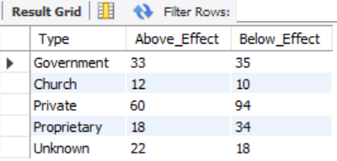

***# Identify hospitals where readmission rates are below the national average***.

***SELECT***

***f.Name, f.City, f.State, r.Readmission***

***FROM***

***facility f***

***JOIN***

***rating r ON f.Facility_ID = r.Facility_ID***

***WHERE***

***r.Readmission = 1;***

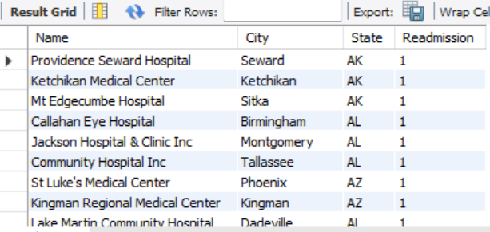

***#Find hospitals where the patient experience is rated above national averages.***

***SELECT***

***f.Name, f.City, f.State, r.Experience AS Experience_rating***

***FROM***

***facility f***

***JOIN***

***rating r ON f.Facility_ID = r.Facility_ID***

***WHERE***

***Experience = 3;***

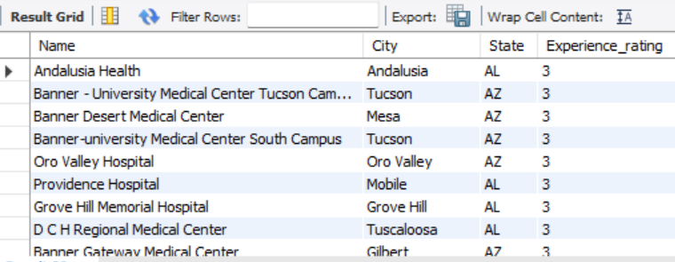

***#List hospitals where timeliness of care is rated as above national average.***

***SELECT***

***f.Name, f.City, f.State, r.Timeliness AS Timeliness_rating***

***FROM***

***facility f***

***JOIN***

***rating r ON f.Facility_ID = r.Facility_ID***

***WHERE***

***Timeliness = 3;***

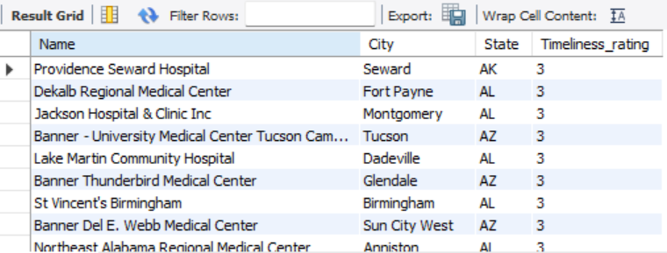

***#Identify hospitals with the most effective use of imaging (rated above the national average).***

***SELECT***

***f.Name, f.City, f.State, r.Imaging AS Imaging_rating***

***FROM***

***facility f***

***JOIN***

***rating r ON f.Facility_ID = r.Facility_ID***

***WHERE***

***Imaging = 3;***

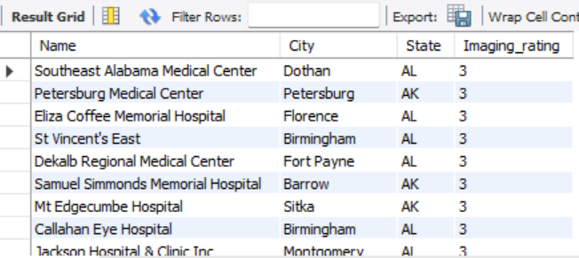

***#Compare the cost and quality of care for heart failure across hospitals.***

***SELECT***

***f.Name, p.Heart_Failure_Cost, p.Heart_Failure_Quality***

***FROM***

***facility f***

***JOIN***

***procedures p ON f.Facility_ID = p.Facility_ID***

***WHERE***

***p.Heart_Failure_Quality = 'Average'***

***ORDER BY p.Heart_Failure_Cost ASC;***

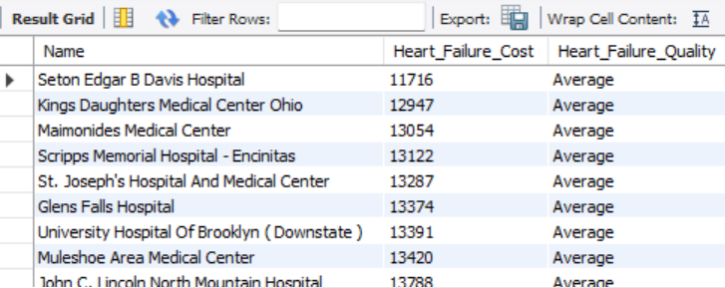

***#Hospitals with Value (Lower) & Cost for Pneumonia Treatment***

***SELECT***

***f.Name, p.Pneumonia_Cost, p.Pneumonia_Value***

***FROM***

***facility f***

***JOIN***

***procedures p ON f.Facility_ID = p.Facility_ID***

***WHERE***

***p.Pneumonia_Value = 'Lower'***

***ORDER BY p.Pneumonia_Cost ASC;***

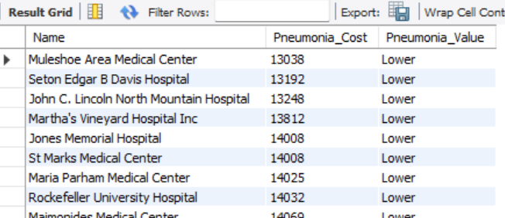

***#Find hospitals with the best value for hip/knee procedures based on cost and quality.***

***SELECT***

***f.Name,***

***p.Hip_Knee_Cost,***

***p.Hip_Knee_Quality,***

***p.Hip_Knee_Value***

***FROM***

***facility f***

***JOIN***

***procedures p ON f.Facility_ID = p.Facility_ID***

***WHERE***

***p.Hip_Knee_Value = 'Lower'***

***ORDER BY p.Hip_Knee_Cost ASC;***

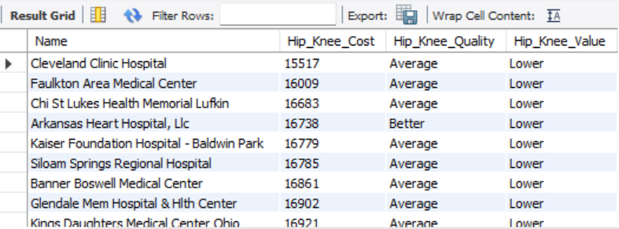

***#Top 5 Hospitals with Best Overall Ratings in Each State***

***SELECT***

***f.Name, f.State, r.Overall***

***FROM***

***facility f***

***JOIN***

***rating r ON f.Facility_ID = r.Facility_ID***

***WHERE***

***r.Overall = 5***

***ORDER BY f.State , r.Overall LIMIT 5;***

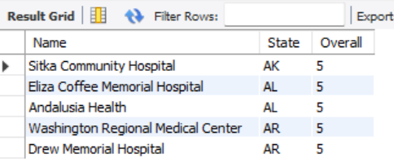

***#Analyze the relationship between heart attack cost and mortality rating.***

***SELECT***

***f.Name, p.Heart_Attack_Cost, r.Mortality AS Mortality_Rating***

***FROM***

***facility f***

***JOIN***

***procedures p ON f.Facility_ID = p.Facility_ID***

***JOIN***

***rating r ON p.Facility_ID = r.Facility_ID***

***WHERE***

***r.Mortality IN ('3' , '1')***

***ORDER BY p.Heart_Attack_Cost DESC;***

